| Name: | **James Lewis** |
| --- | --- |
| **Roll No:** | **32** |
| **Class/Sem:** | TE/V |
| **Experiment No.:** | 2 |
| **Title:** | Implementation of Dimension and Fact tables and perform OLAP operations. |
| **Date of Performance:** |  |
| **Date of Submission:** |  |
| **Marks:** |  |
| **Sign of Faculty:** |  |

**Aim:** Implementation of Dimension and Fact tables and perform OLAP operations.

**Objective:** OLAP stands for Online Analytical Processing. The objective of OLAP is to analyze information from multiple database systems at the same time. It is based on a multidimensional data model and allows the user to query on multi-dimensional data.

**Theory:**

* Online Analytical Processing Server (OLAP) is based on the multidimensional data model.
* The main aim of OLAP is to provide multidimensional analysis to the underlying data.

Following is the list of OLAP operations:

1. Roll-up
2. Drill-down
3. Slice
4. Dice
5. Pivot (rotate)

**Roll-up:**

* The roll-up operation (also called the drill-up operation) performs aggregation on a data cube, either by climbing up a concept hierarchy for a dimension or by dimension reduction.
* Figure 2.1 shows the result of a roll-up operation performed on the central cube by climbing up the concept hierarchy for location.
* This hierarchy was defined as the total order “street < city < province or state < country.”
* The roll-up operation aggregates the data by ascending the location hierarchy from the level of the city to the level of the country.
* In other words, rather than grouping the data by city, the resulting cube groups the data by country.

**Drill-down:**

* Drill-down is the reverse of roll-up. It navigates from less detailed data to more detailed data.
* Drill-down can be realized by either stepping down a concept hierarchy for a dimension or introducing additional dimensions.
* Figure 2.1 shows the result of a drill-down operation performed on the central cube by stepping down a concept hierarchy for time defined as “day < month < quarter < year.”
* Drill-down occurs by descending the time hierarchy from the level of quarter to the more detailed level of month.
* The resulting data cube details the total sales per month rather than summarizing them by quarter.

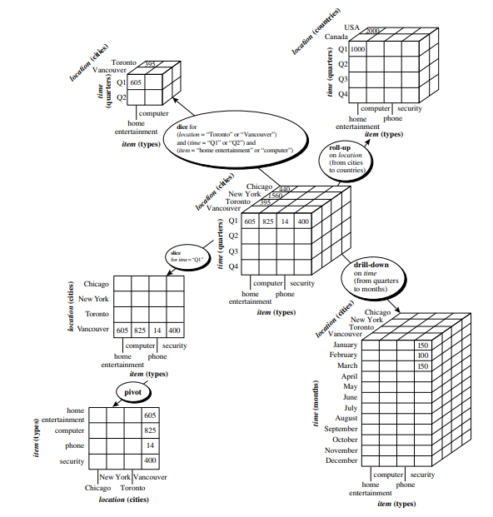

**Figure 2.1: Examples of typical OLAP operations on multidimensional data.**

**Slice:**

* The slice operation performs a selection on one dimension of the given cube, resulting in a sub cube.
* Figure 2.1 below shows a slice operation where the sales data are selected from the central cube for the dimension time using the criterion time = “Q1.”

**Dice:**

* The dice operation defines a sub cube by performing a selection on two or more dimensions.
* Figure 2.1 shows a dice operation on the central cube based on the following selection criteria that involve three dimensions: (location = “Toronto” or “Vancouver”) and (time = “Q1” or “Q2”) and (item = “home entertainment” or “computer”).

**Pivot:**

* Pivot (also called rotate) is a visualization operation that rotates the data axes in view to provide an alternative data presentation.
* Figure 2.1 shows a pivot operation where the item and location axes in a 2-D slice are rotated.

**Problem Statement:**

Design and implement a data warehouse schema using MySQL Workbench to store and analyze sales data through Online Analytical Processing (OLAP) techniques. The schema should include appropriate dimension and fact tables based on a star schema model. Populate the warehouse with sample data and perform OLAP operations such as Roll-up, Drill-down, Slice, Dice, and Pivot to simulate real-world multidimensional analysis.

**Output:**

1. Creating the Dimension Tables
2. Creating the Fact Table
3. Inserting values in both dimension and fact tables
4. Displaying the tables
5. Write SQL Queries for all the above OLAP operations.

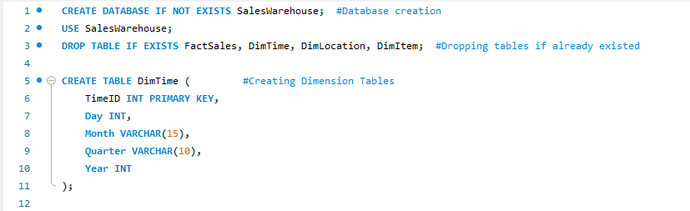

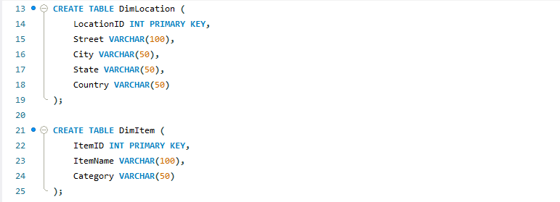

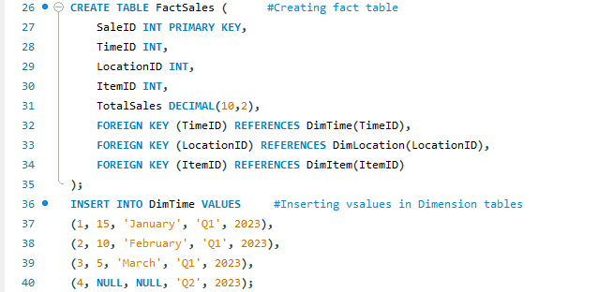

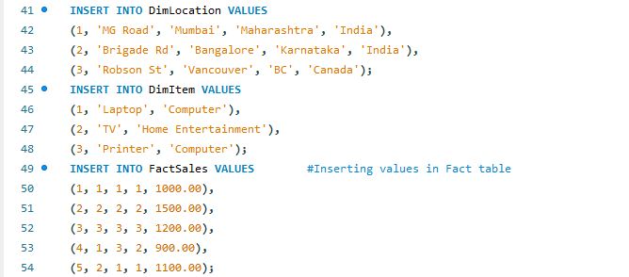

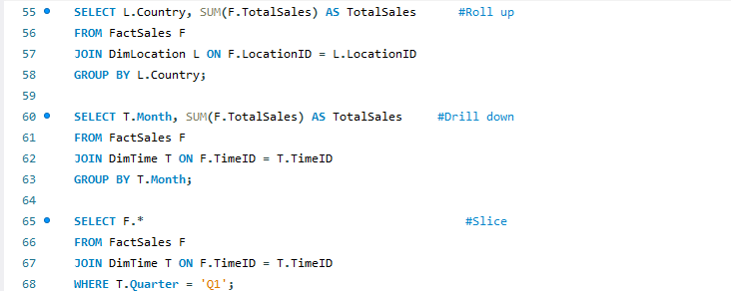

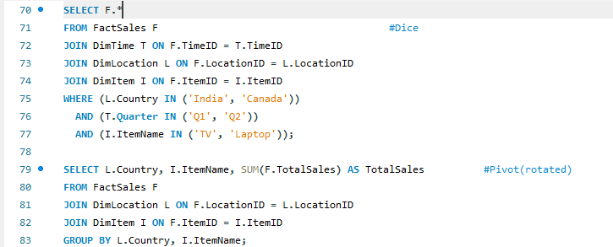

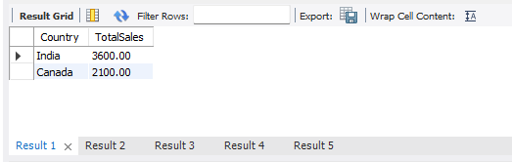  
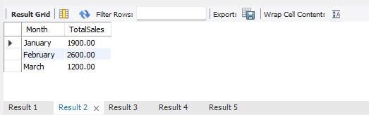

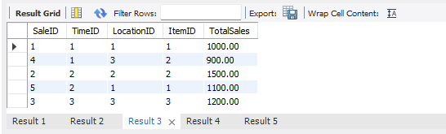

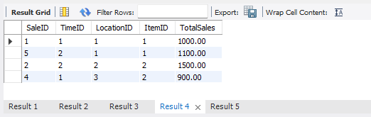

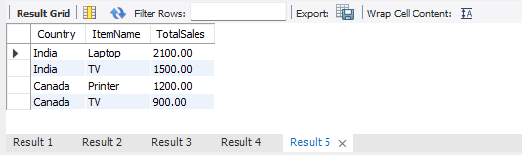

**Conclusion:**

**Q1. What is the importance of OLAP operations?**

OLAP (Online Analytical Processing) operations are fundamental in data analysis and business intelligence because they enable users to interactively explore, analyze, and gain insights from large volumes of multidimensional data. Here's why OLAP operations are important:

1. Efficient Data Analysis: OLAP operations allow quick retrieval and summarization of data, enabling users to analyze complex data sets without writing complex queries. This speeds up decision-making.
2. Multidimensional View: OLAP supports data analysis across multiple dimensions (e.g., time, geography, product), providing a comprehensive view of business performance.
3. Data Aggregation: Operations like roll-up and drill-down help in aggregating data at different levels of granularity. For example, you can view sales data by year (roll-up) or by month (drill-down).
4. Slice and Dice: This operation allows users to focus on specific data subsets by selecting particular dimensions or values, facilitating targeted analysis.
5. Pivoting (Rotate): It helps in reorienting the multidimensional view, making it easier to visualize and compare data across different dimensions.
6. Improved Decision-Making: By providing fast and flexible data exploration, OLAP operations empower business users to identify trends, patterns, and anomalies, leading to better strategic decisions.
7. User-Friendly: OLAP tools often come with intuitive interfaces, allowing non-technical users to perform complex analyses without deep technical knowledge.

In summary, OLAP operations are crucial because they transform raw data into actionable insights by enabling dynamic, interactive, and multidimensional data analysis, which is essential for effective business intelligence and decision-making.

**Q2. What are the key features of OLAP?**

The key features of OLAP (Online Analytical Processing):

1. Multidimensional Analysis  
    OLAP allows data to be modeled and viewed in multiple dimensions (e.g., time, geography, product). This lets users analyze data from different perspectives easily.
2. Fast Query Performance  
    OLAP systems are optimized to provide quick responses to complex queries, enabling real-time or near-real-time data analysis.
3. Aggregations and Summarization  
    OLAP can perform aggregations like sums, averages, counts, and other calculations across different levels of data hierarchies (e.g., daily, monthly, yearly sales).
4. Hierarchical Data Organization  
    Data is often organized in hierarchies within dimensions (e.g., Country > State > City). This supports drill-down (detailed view) and roll-up (summary view) operations.
5. Slice and Dice Capability  
    Users can select and view specific slices of data by filtering particular dimensions or values, helping to focus on relevant data subsets.
6. Pivot (Rotate)  
    OLAP allows the reorientation of the multidimensional view, switching rows and columns or changing the dimensional perspective to analyze data differently.
7. Complex Calculations and Derived Metrics  
    OLAP supports advanced calculations like ratios, percentages, and moving averages, often defined by users for better insights.
8. Time Intelligence  
    OLAP systems are designed to handle time-series data efficiently, supporting comparisons over periods (e.g., year-over-year growth).
9. User-Friendly Interface  
    Typically, OLAP tools provide intuitive drag-and-drop interfaces for users to build queries and reports without needing deep technical skills.
10. Support for Large Volumes of Data  
     OLAP is built to handle and analyze huge datasets effectively.